
AMERICAN INTERNATIONAL UNIVERSITY–BANGLADESH (AIUB)
FACULTY OF SCIENCE & TECHNOLOGY
DEPARTMENT OF PHYSICS
PHYSICS LAB 6
Fall 2023-2024

LAB REPORT ON
- Study of Ohm’s law using unknown resistances.
- Determination of the equivalent resistances for series and parallel combinations of resistors.
Supervised by
DR. KAMRUN NAHAR MUKTA
Submitted By
S. N. | Name | ID | Contribution
1 | Farhan Chowdhury | 23-52314-2 | Experimental Data, Discussion, Theory
2 | Nayem Siddiki | 23-52361-2 | Theory, Discussion, Reference, Calculation
3 | Fahim Al Noor | 23-51977-2 | Analysis, Discussion, Result, Theory
4 | Amanur Rahman | 23-52039-2 | Procedure, Discussion, Reference, Theory
5 | Mubashshirul Islam | 23-52322-2 | Apparatus, Result, Discussion

Submission: 23 July 2023
TABLE OF CONTENTS

Topic | Page no
Title Page | 1
Table of Contents | 2
- Theory | 3
- Apparatus | 5
- Procedure | 5
- Experimental Data | 6
- Calculations | 7
- Result | 7
- Discussion | 7
- Reference | 7

- Theory:

Ohm's Law is a fundamental principle in electrical engineering and physics that describes the relationship between voltage, current, and resistance in an electrical circuit.
Ohm's Law states that the current passing through a conductor between two points is directly proportional to the voltage across the two points and inversely proportional to the resistance of the conductor. Mathematically, Ohm's Law is represented as:
V = I x R
Where:
- V is the voltage across the conductor (measured in volts, V).
- I is the current flowing through the conductor (measured in amperes, A).
- R is the resistance of the conductor (measured in ohms, Ω).
In simple terms, this law states that the current through a conductor increases with an increase in voltage and decreases with an increase in resistance.
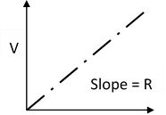
It's important to note that Ohm's Law is applicable only to passive components like resistors, and not to components like diodes and transistors, which exhibit more complex behavior. However, for many practical applications involving resistors and simple circuits, Ohm's Law is crucial and useful.
𝑉 = 𝐼𝑅
Here,
𝑉 = Potential Difference
𝐼 = Current
𝑅 = Resistance Figure – 2: Slope of the V vs I graph gives the value of R.
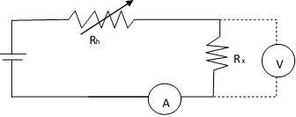

Figure – 1: Simple circuit to determine unknown resistance (R_{x}) by using Ohm’s law. Ammeter (A) and volt meter(V) are used to measure the current and potential drop in the circuit, variable resistor, Rh is used to change the current flow in the circuit.
When N number of resistors are connected in series and parallel connections their equivalent resistances R_{s} and R_{p} are calculated by the following two equations:
1 1 1 1 𝑹_{𝒔} = 𝑹_{𝟏} + 𝑹_{𝟐} + ⋯ + 𝑹_{𝑵,} 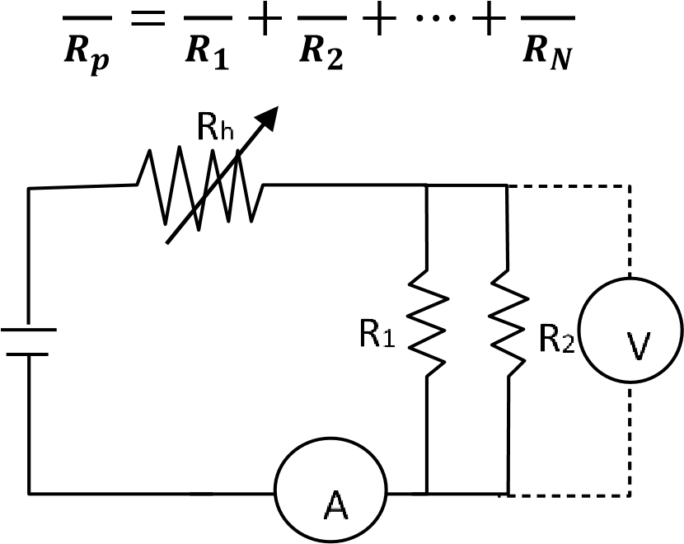
Figure – 3: Series connection for two unknown resistors R₁ & R₂.
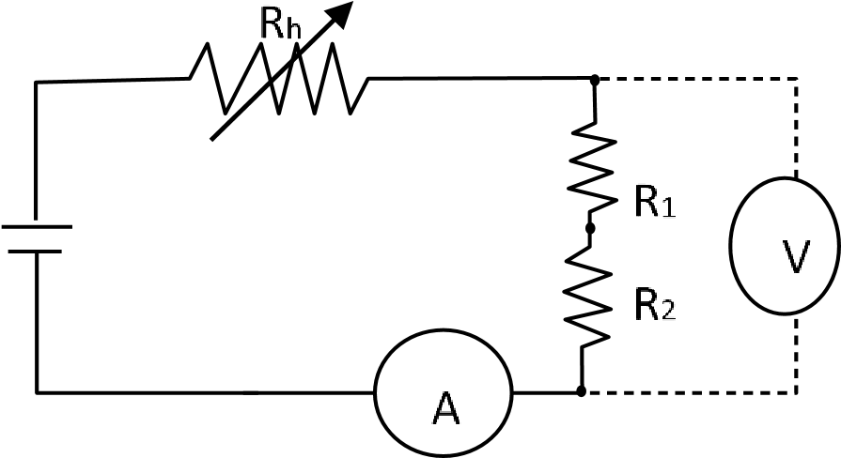
Figure – 4: Parallel connection for two unknown resistors R₁ & R₂.

- Apparatus:
- Power Supply
- Variable Resistor or Rheostat
- Ammeter
- Voltmeter
- Unknown Resistors
- Connecting Wires

- Procedure:
  - Two unknown resistances, R₁ & R₂, were used to construct the above circuits.
  - The rheostat (R) was employed, and a current value of less than 1A was selected.
  - For six different currents, the value of (Rh) was varied, and the ammeter (A) readings were recorded.
  - The corresponding potential differences in the voltmeter (V) were also measured.
  - V vs I graphs of R₁, R₂, R₁ & R₂ in series, and R₁ & R₂ in parallel were plotted using EXCEL.
  - The best fit lines were determined, and the slope of the best fit lines was calculated to find the values of R₁, R₂, R_{p} & R_{s}.
  - The values of Rp & Rs were also calculated in accordance with the laws of series and parallel combinations of resistors using the values of R₁ & R₂.

- Experimental Data:
Table 1: Voltageand and Current records for R₁ and R₂
Resistors | Current  I(A) | Voltage  V(V)
R1 | 0.1 | 0.138
R1 | 0.2 | 0.230
R1 | 0.3 | 0.310
R1 | 0.4 | 0.450
R1 | 0.5 | 0.520
R1 | 0.6 | 0.630
R2 | 0.1 | 0.270
R2 | 0.2 | 0.520
R2 | 0.3 | 0.770
R2 | 0.4 | 0.910
R2 | 0.5 | 1.000
R2 | 0.6 | 1.310

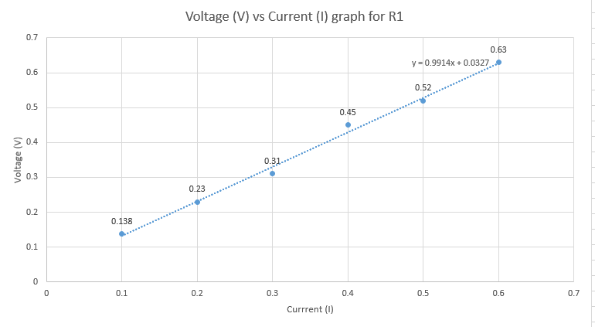
Graph 1 : Voltage (V) vs Current (I) graph for R₁

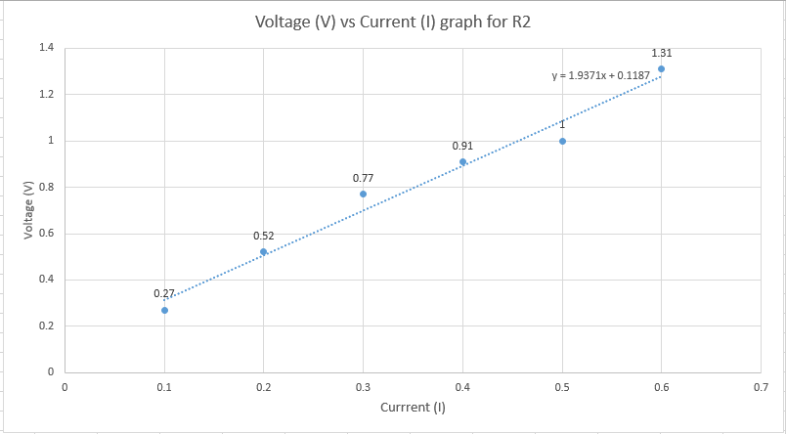
Graph 2 : Voltage (V) vs Current (I) graph for R₂

Table 2: Voltage current records for series and parallel connections.
Combinations of R₁ and R₂ | Current  I(A) | Voltage  V(V)
Series Combination | 0.1 | 0.430
Series Combination | 0.2 | 0.600
Series Combination | 0.3 | 0.960
Series Combination | 0.4 | 1.400
Series Combination | 0.5 | 1.620
Series Combination | 0.6 | 2.00
Parallel Combination | 0.1 | 0.078
Parallel Combination | 0.2 | 0.150
Parallel Combination | 0.3 | 0.220
Parallel Combination | 0.4 | 0.280
Parallel Combination | 0.5 | 0.380
Parallel Combination | 0.6 | 0.480

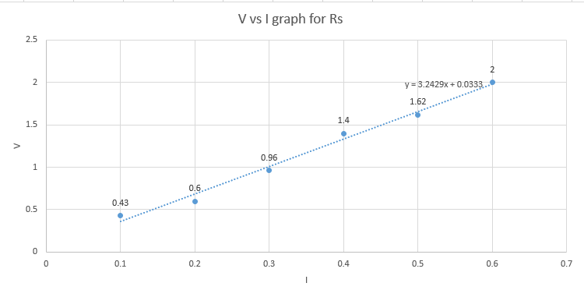
Graph 3 : Voltage (V) vs Current (I) graph for R_{s}

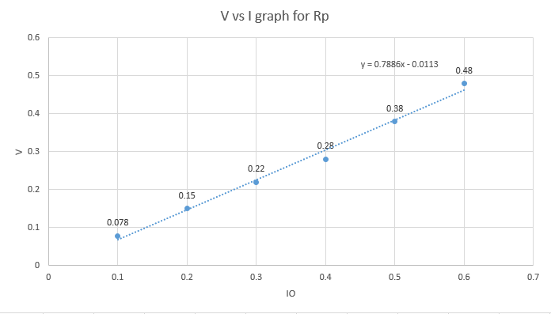
Graph 4 : Voltage (V) vs Current (I) graph for R_{p}

- Calculations:

- Value of R₁ from graph = 0.9914 Ω
- Value of R₂ from graph = 1.9371Ω
- Calculated value of R₁ & R₂ in series:
𝑅_{𝑠} = 𝑅₁ + 𝑅₂
_{or,} 𝑅_{𝑠 =0.9914+1.9371}
_{or,} 𝑅_{𝑠 =2.9285 Ω}
- Calculated value of R₁ & R₂ in parallel:
1 1 1
= +
𝑅𝑝 𝑅1 𝑅2
𝑜𝑟, 𝑅_{𝑝} = $\frac{R1 ×R2}{R1+R2}$= 0.6
or, R_{p} $= \frac{0.9914×1.9371}{0.9914+1.9371}=0.655$

- Result:
Resistances from the graphs |  | Calculated Values of R_{s} and R_{p} in Ohms | Comments
Resistors | Values in Ohms | Calculated Values of R_{s} and R_{p} in Ohms | The discrepancies between the calculated value of Rs and Rp with their graphical values is a result of not having enough accuracy of the values taken when calculating results.
R₁ | 0.9914 Ω | Calculated Values of R_{s} and R_{p} in Ohms
R₂ | 1.9371 Ω | Calculated Values of R_{s} and R_{p} in Ohms
R_{s} | 3.2429 Ω | 2.9285 Ω
R_{p} | 0.7886 Ω | - Ω

- Discussion:
Ohm's Law states that the current passing through a conductor is directly proportional to the voltage applied across it and inversely proportional to its resistance. By using an unknown resistance, students can validate the law's accuracy and understand the relationship between voltage, current, and resistance. In this experiment, a circuit is constructed with a known voltage source, ammeter, and the unknown resistor. The voltage across the resistor and the current passing through it are measured. By plotting the current-voltage relationship, students can determine the resistance value. This process allows students to grasp the concept of resistance and how it affects the flow of current in a circuit.

- References:
Fundamental of Physics (10t Edition): Ohm's Law (Chapter 26, page 756-759)
• Video Links:
https://www.voutube.com/watch?v=Vh3XG77hgU4 https://www.youtube.com/watch?v=hxYn74Yhkok
https://www.voutube.com/watch?v=2c1z4pLsI_w

